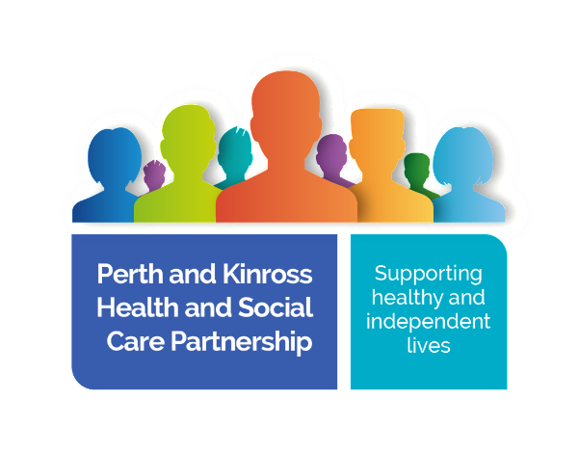

**Community Care and Treatment Service (CCATS)**

**Bridge of Earn Community Hub**

**Patient information leaflet**

The aim of this leaflet is to provide you with information about the Community Care and Treatment Service (CCATs) being delivered in **Bridge of Earn.**

The service is for ambulatory adults 16 years of age and over) who are able to visit the clinic presenting with:

* Simple dressings, for example burns, accidental injuries
* Trauma wounds (after initial assessment)
* Suture/clip/drain removal
* Post operative wounds
* Leg ulcer assessment and management. Doppler assessment/ Compression bandaging.
* Complex wounds, for example leg ulcers, non healing wounds, wounds that need packed.

We work on an appointment based clinic system and clinics are held within Bridge of Earn community clinic.

**The locality team is currently made up of**

Senior Charge Nurse/Team leader   
  
2 Charge Nurses

4 Registered Nurses

7 Health Care Support Workers

The team work across the whole of the locality so you may see different members of the team on different days when you attend.

**What do we offer in the Bridge of Earn clinic**

* Blood clinics for non-urgent bloods (appointments initiated by the GP practice)
* Chronic disease monitoring including blood pressure, height, weight, diabetic checks (appointments initiated by the GP practice)
* Wound care including leg ulcer assessment and management
* Ear irrigation
* Warfarin monitoring

**How do I make an appointment?**

Our operational hours are 08.30-16.30 but appointment times can be flexible.

You can make an initial appointment by contacting your GP practice and asking for an appointment with the wound care clinic or blood clinic in Bridge of Earn. Blood and chronic disease monitoring appointments are under the remit of the GP practice who will inform you if blood tests and/or reviews are required. Any ongoing wound care/warfarin appointments will be made by the nurse attending to you.

We ask that patients adhere to appointment times as much as possible as the clinic is very busy at times

**Who we work with**

We work together with a number of other healthcare professionals who may be involved with your care, for example:

* GPs
* District nurses
* Dermatology services
* Vascular services
* Podiatry services

**What can you expect from the service?**

* A safe, professional, courteous service
* Confidentiality
* Appropriate referral to other services where appropriate
* Continuity of care
* Individual assessment and care planning

.

The clinics in Bridge of Earn will operate on a Tuesday and Thursday currently but we offer a 5 day service for the locality. If you have an urgent enquiry that cannot wait until your next appointment you can get in touch via your GP practice.You may be asked to attend an appointment at a different site if you require to be seen promptly.

We welcome feedback about the service so your comments and/or concerns can be discussed in the first instance with the nurse.