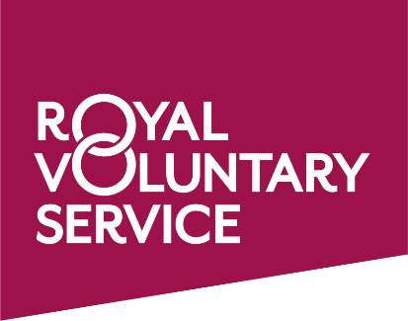

The Royal Voluntary Service provide a social transport service designed to take older and vulnerable people to and from medical, health or social appointments. The service is delivered by friendly and trained volunteer drivers who will transport you to your appointment, and if it is short, will wait for you and take you home when finished. The service is charged at £4.20 for the first 3 miles and 65p per mile thereafter with payments made through an invoicing process with no money changing hands during the journey.
If you would like to register as a client with the Royal Voluntary Service and take advantage of our transport service and easy booking system, then please call the office on 01738 633975 or call the transport coordinator mobile number 07880026305.
If you have your own car and some time on your hands and you would like to enquire a little more about being a Royal Voluntary Service volunteer driver, we would love to hear from you; all expenses paid. Please call Geoff Bird (Service Manager) on 07834482364.

