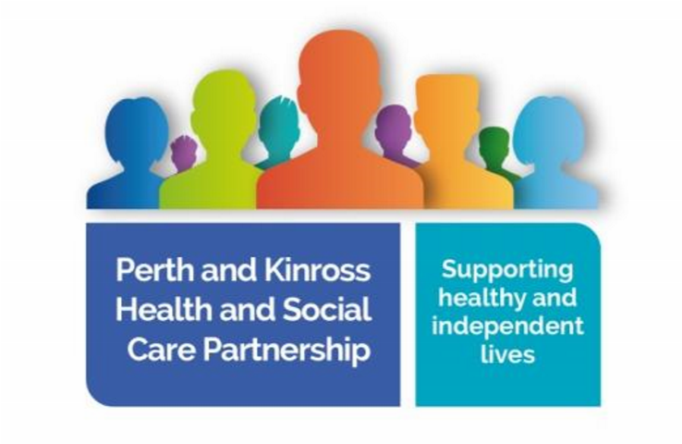
Perth & Kinross Health and Social Care Partnership

Earn Community Council

By email: secretaryearncc@gmail.com

Italics indicates the questions raised by Earn Community Council

Thank you for your correspondence of 26 January 2021, please accept my apologies for the delay in responding.

New Facility in the Old Nurses House at Bridge of Earn

The new facility in the Old Nurses House is a welcome addition to the area and we look forward to all the support being in place. There are a number of questions that would be good to clarify:

- Can local residents access treatments available at the nurse’s house directly, or are they accessed only via their GP? If the latter, are all GP surgeries supporting local residents accessing the facility?
- If it is the former, how do local residents know of the facilities and treatment available? Poor communication has let the good intentions of your office down in the past.
- When, given the Covid situation, do you think the full range of facilities will be available?
- Are the treatments offered done within the facility alone, or are the nurses going to the homes of patients, or both?

This facility can only be accessed by referral from a GP Practice, ongoing treatment is then arranged with the individual patient by the Care and Treatment Nursing Team. The GP practices in Perth, Kinross and Abernethy are all aware of how to access the facility and clinics and all GP practices use ‘Vision Anywhere’ which allows them to arrange patient appointments at the Care and Treatment Service based at the Old Nurses House in Bridge of Earn.

The full range of facilities will be on offer by April 2021 and this will be promoted within the local community. We have not been able to have a formal opening of the Nurses House due to COVID but have advertised the opening in the local paper with promotional pictures. The facility will deliver wound care treatments, suture removal, phlebotomy and chronic disease monitoring. Minor Injury appointments will be built into the wound care clinics over the coming months once staff have received further triage and clinical assessment training. Our mental health teams and social prescribers can also book to use the facility at any time, to see patients. However, you will appreciate that due to COVID restrictions most consultations are being undertaken remotely using technology such as ‘Near Me’.

The treatments that the HSCP are providing in the facility were traditionally delivered within a GP Practice by the practice nursing teams and, as such, all treatment is offered in the clinic setting. Our District Nursing Service continues to support patients who are unable to leave their home.

We have also appointed an Advanced Nurse Practitioner who works alongside GP Practices to support Urgent Care in the area, by providing home visits to support the workload of GPs. This role is one of high clinical expertise and allows a full health assessment for those who may be too frail or unwell to leave their home. We have also developed a new model of locality integrated care named LInCS. This service involves a team who are able to wrap round an individual to ensure that we intervene early when their health deteriorates. This team involves all health and social care professionals and offers a rapid response to enable people to remain at home, when appropriate, but to receive quick and appropriate intervention with physical health issues. GPs across Perth & Kinross have access to the LInCS service.

Planning at Oudenarde

With regard to new housing and the most recent information regarding of planning going ahead at Oudenarde:
- Can you confirm that your offices are aware of the new proposed development plans and that these will be considered in any future strategic plan for the area?
- When will this new strategic plan be finalised and can we as a Community Council have further input into the process?

We are aware of the proposed development at Oudenarde. The HSCP is currently assessing future primary care needs across Perth and Kinross communities, including the need for premises. This will be presented to the NHS Tayside Asset Management Group, as the responsibility for premises and capital investment lies with the Health Board, rather than the HSCP.

- It does seem obvious that a practice at BofE would help alleviate pressure on the Perth GP practices. There have been a number of reports conveying the pressure they are under, especially with the additional patient numbers from BofE; (straw and camel backs come to mind).

The HSCP have not been alerted either through Primary Care services in NHS Tayside or from a local perspective to any added pressures due the dispersal of patients from the former Bridge of Earn GP practice, neither have we received any complaints.

- In paragraphs 7, you rightly point out that there are no suitable premises, but this is surely at the crux of the matter and has been for some time. There is land available, a potential new build premises proposed and there are existing facilities that could be converted as part of a bigger strategic plan for the area. This larger plan must include other aspects of community, including Education. It would seem obvious that a further development of housing at Oudenarde would result in expansion of educational needs and so an overarching, coordinated plan is what is needed and not a sticking plaster.

In general the HSCP acknowledge a GP practice in Bridge of Earn/Oudenarde could potentially help to address the wider health needs and requirements of Bridge of Earn and surrounding areas. However, the development of a new practice would have to be commissioned by NHS Tayside and procured by NHS Procurement Scotland, this is not a function that the HSCP can deliver on. Over and above the development of a new GP contract, NHST are responsible for the capital planning of a new building.

Turning to your latter points regarding future planning:

i. Can you expand on what a 17J contract is and what is provided by each party (GP, Council and Health Board).

A section 17J or GMS (General Medical Services) contract is a standard, nationally negotiated contract. Within the contract there is some flexibility in the contract for GPs to opt out of certain services or opt in to the provision of others. Section 17J is in respect of the National Health Service (Scotland) Act 1978, as amended under the Primary Medical Services (Scotland) Act 2004.

- Is this the only option available to the community?

The community of Bridge of Earn cannot commission a practice as this is a regulatory requirement for NHS Tayside to deliver upon.

- Can you please explain what you mean by “Wider Assessment Needs” and where BofE and surrounding area fit into this larger plan?

This refers to the opportunity to progress partnership work with NHS Tayside, the developer at Oudenarde and Perth and Kinross Council to scope out the potential for a multi-agency facility there, which could provide a range of local health, Council and care services to the benefit of the community. This would require the participation and commitment of all parties and as you will appreciate the potential to explore this has been severely curtailed by the focus partners are giving to the pandemic.
I trust this information is helpful.

Chief Officer/Director – Integrated Health & Social Care

